Types of Electrophoresis

Electrophoresis is a technique used to separate macromolecules in a fluid or gel based on their charge, binding affinity, and size under an electric field. In the year 1807, Ferdinand Frederic Reuss was the first person to observe electrophoresis. He was from Moscow State University. Anaphoresis is the electrophoresis of negative charge particles or anions whereas cataphoresis is electrophoresis of positive charge ions or cations. [Electrophoresis](https://byjus.com/chemistry/electrophoresis-technique-used-for-dna-analysis/) has a wide application in separating and analysing biomolecules such as proteins, plasmids, RNA, DNA, nucleic acids.

Electrophoresis Principle and its types:

Charged macromolecules are placed in the electric field move towards the negative or positive pole based on their charge. Nucleic acid has a negative charge and therefore it migrates towards the anode.

This technique is divided into two types viz slab electrophoresis and capillary electrophoresis.

Types of Electrophoresis:

1. Capillary electrophoresis
   1. Gel electrophoresis
   2. Paper electrophoresis
2. Slab electrophoresis
   1. Zone electrophoresis
   2. Immunoelectrophoresis
   3. Isoelectrofocusing

Gel electrophoresis procedure:

Below we have explained the steps conducted during DNA electrophoresis.

Step 1: Prepare sample –

Isolate the DNA and prepare the solution by adding blue dye so that it will be easy to observe the movement of the sample taking place in the gel.

Step 2: Prepare an agarose TAE gel solution –

TAE [buffer solution](https://byjus.com/jee/buffer-solutions/) helps to generate an electric field during the process of electrophoresis. To prepare the solution, for example, if there is a requirement of 1% agarose gel then add 100mL TAE to 1 g of agarose. The higher percentage of agarose will give a denser screen. Dissolve the agarose by heating the agarose TAE solution.

Step 3: Gel casting –

Pour the agarose TAE solution in a casting tray. Allow it to cool and solidify. A gel slab along with the wells is ready to use for the experiment.

Step 4: How to set up the electrophoresis chamber?

Fill a chamber with TAE buffer. Place the solid gel in the chamber. Place the gel in such a position such that it is near the negative electrode.

Step 5: Gel loading –

Load the wells with the DNA sample and DNA ladder (a reference for sizes).

Step 6: Process of electrophoresis –

Connect the positive and negative points to the power supply and chamber. Switch on the power and migration in the DNA sample due to the electric field generated. The negatively charged sample will move towards the positive point and away from the negative [electrode](https://byjus.com/chemistry/electrodes/).

Step 7: Observe the DNA –

Once you see the migration of the blue colored DNA samples in the gel switch off the power supply. Remove the gel and place it in the ethidium bromide solution.

Step 8: Expose the ethidium bromide stained gel under UV light and take a picture. DNA bands appear in the lane of respective well. Also, the DNA ladder is visible. Therefore, the length of DNA bands can be determined. Below is the image of the experiment conducted.

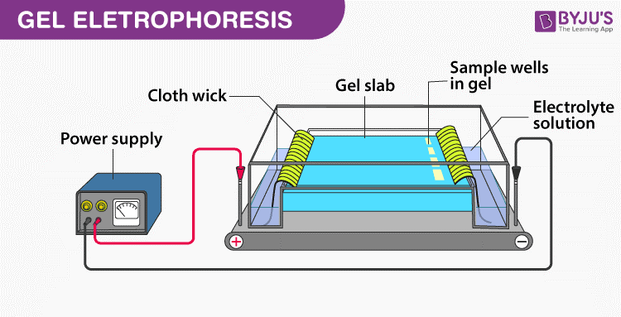

Immunoelectrophoresis procedure:

1. Prepare agarose gel on a glass slide in a horizontal position.
2. Use sample template and carefully move the wells to the application zone.
3. Make the sample dilution in the ratio 2:3 with the diluent protein solution.
4. Take a 5 μl pipette and add 5 μl of sample and control across each slit.
5. Place the gel in the chamber for electrophoresis positioning the sample near the cathode side. Carry out the electrophoresis for 20 mins at 100 volts.
6. Take 20 μl of antiserum in a trough and incubate for 8- 20 hours at room temperature on competing the electrophoresis.
7. Soak the agarose gel for 10 minutes in saline solution, dry it and wash it twice.
8. Dry the gel below 70°C and stain it with protein stain solution for 3 minutes. Decolorize the gel in destaining solution for 5 minutes.
9. Determine the results once the gel is dried.

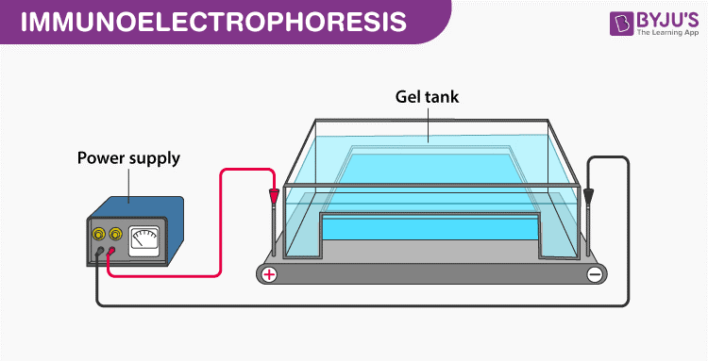

# Types of Electrophoresis – Principles and Applications

Electrophoresis is a process that separates charged particles in a fluid with the aid of the field of electrical charge. In life sciences, an electrophoresis is a vital tool that separates protein molecules or DNA according to its size and type.

In a laboratory setting, electrophoresis is used to separate molecules according to heir size, purity, and density.

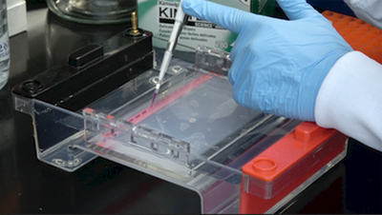

## Paper electrophoresis

It is probably the simplest type of electrophoresis wherein the sample is applied on a strip of filter paper moisturized with a buffer solution.

The end of the strip is dipped into separate tanks that have a buffer solution and different electrodes. A current is applied which will make the sample move towards the electrode with opposite polarity. The strip is dried and checked under the detection system.

## ****Agarose gel electrophoresis****

It uses an agarose gel to separate fragments of DNA or RNA of varying lengths. It observes the movement of negatively charged RNA or DNA molecules from the negative electrode to the positive ones. The molecules are differentiated according to the size of molecules.

## Polyacrylamide gel electrophoresis

there are two types of gels used – dissociating and non-dissociating. The non-dissociating gel separates proteins in the original form thereby conserving the structure, function, and activity of the protein. On the other hand, the dissociating gel denatures protein into polypeptides to find out the compositionof a given sample. ***(1, 2, 3, and 4)***

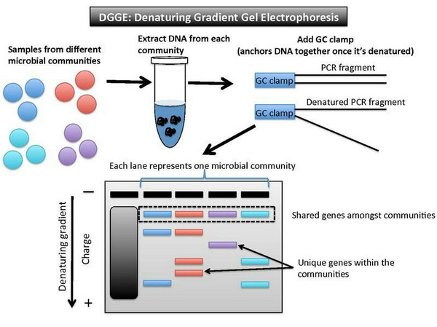

**Image 2:** The image above described how DGGE works.

**Applications**

– Analyzing proteins in physiological matrices (eg.Serum, urine) – DNA analysis – Drug screening. – Analysis of pesticides, food content, pollutants.

**Specific Applications** • Neoplastic disorders – Detection of tumor-related mutation. – Microsatellite instability – Analysis of monoclonality. • Diagnosis of hereditary diseases and prenatal testing • Diagnosis of infectious diseases • Identity testing